**COGNIZANT**

**Week- Hands on**

**Assignments**

**React**

**Name: *Pranesh E S***

**Super Set ID: *6393970***

**E-mail:**[***pranesheswaran@gmail.com***](mailto:pranesheswaran@gmail.com)

**React**

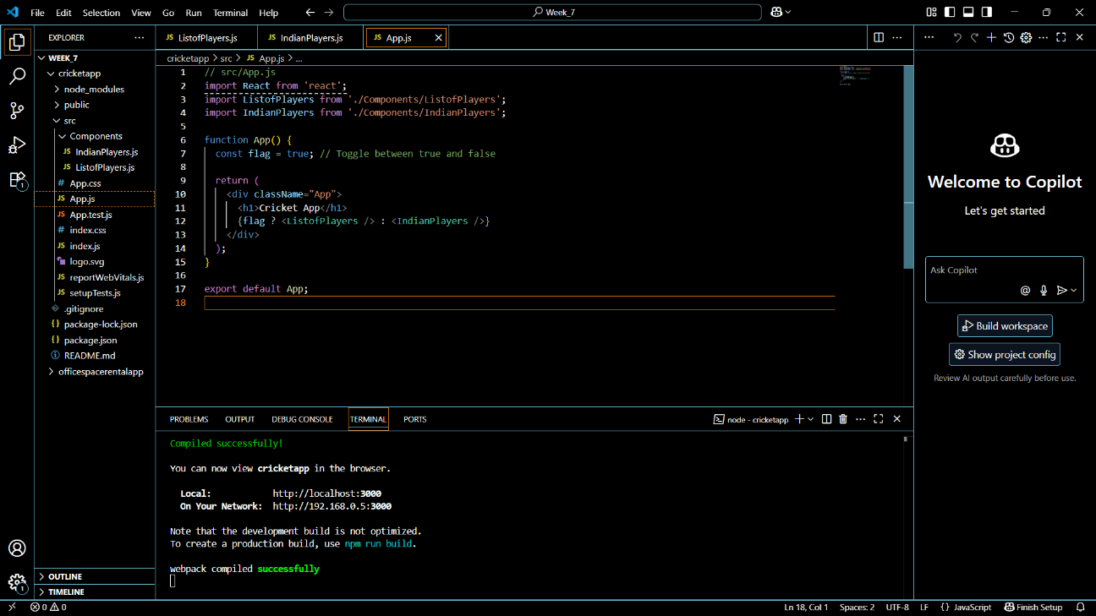**Question-1(Cricket app)**

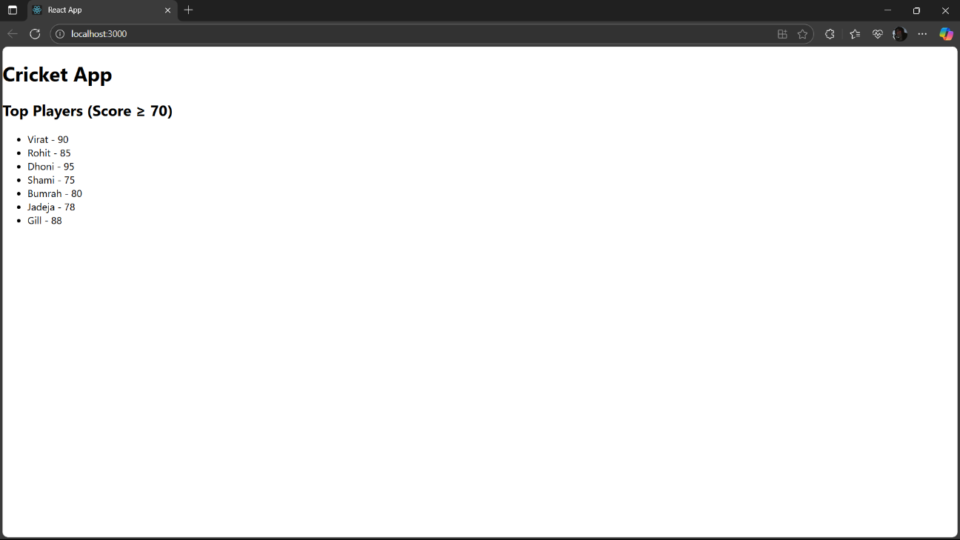

**Question-2(Office space rental app)**

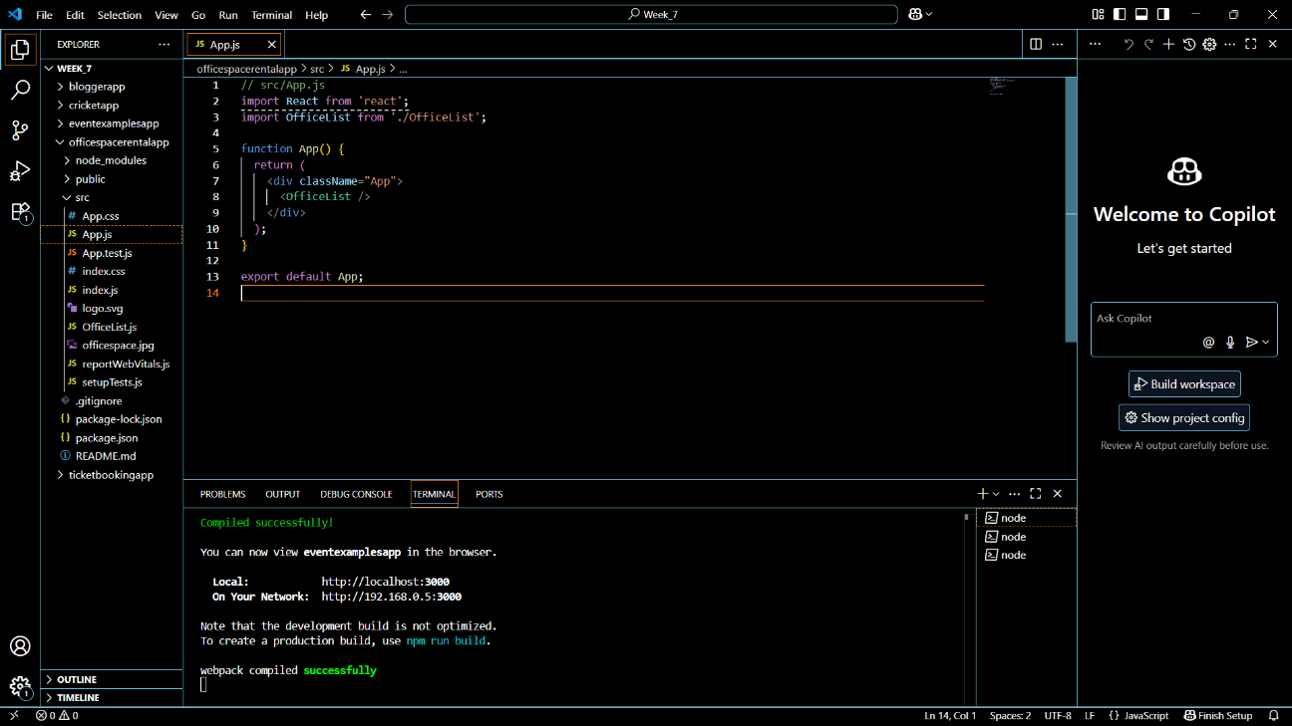

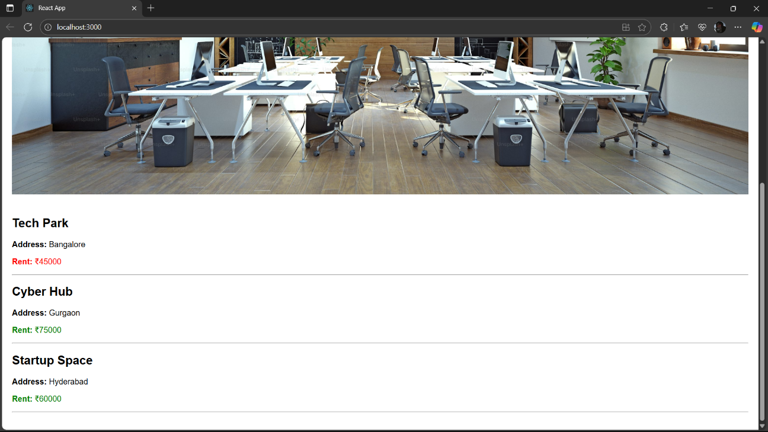

**Question-3(Event examples app)**

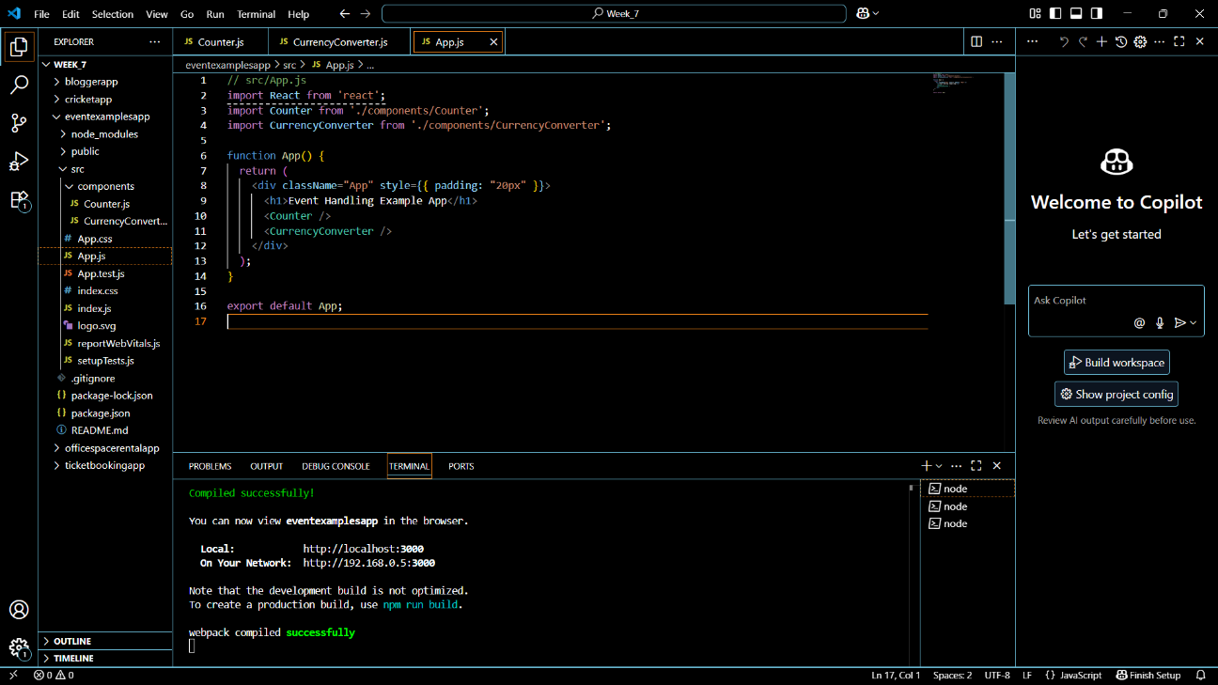

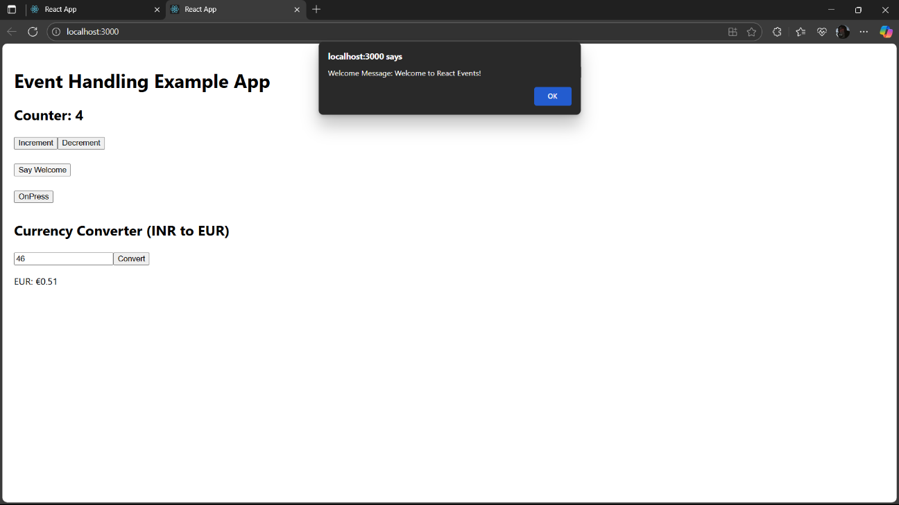

**Question-4(Ticket booking app)**

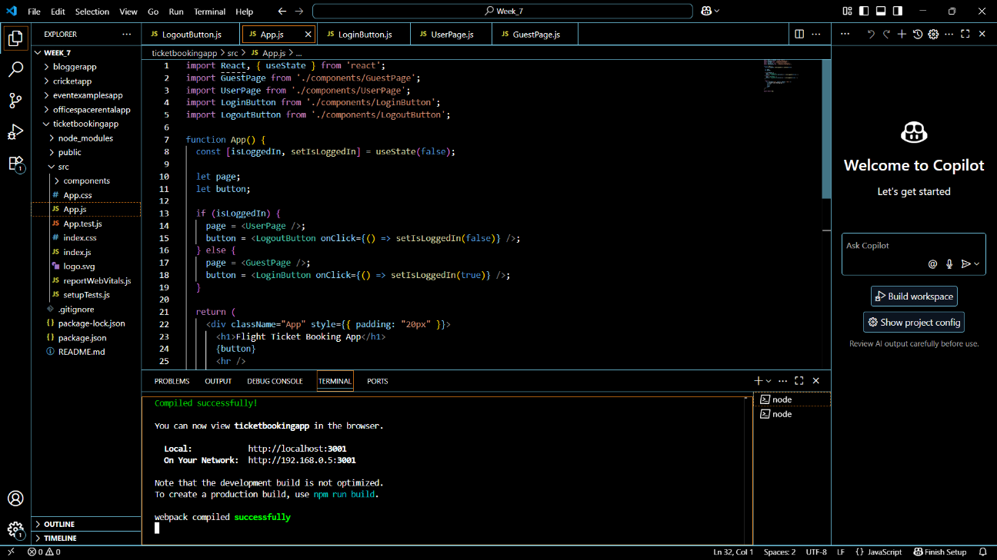

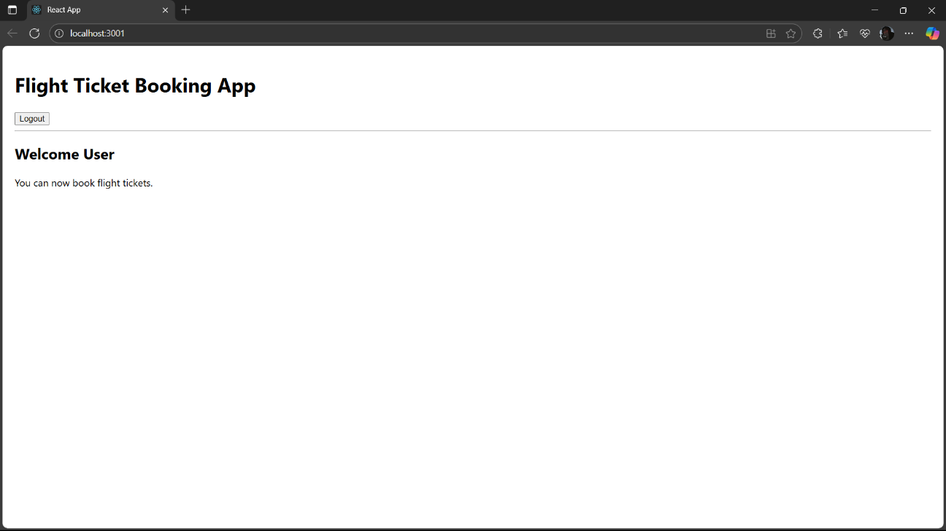

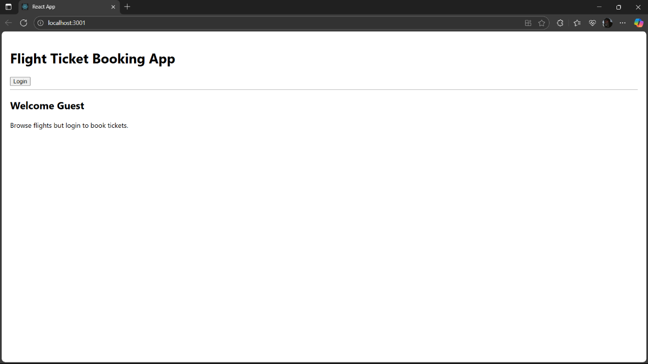

**Question-5(Blogger app)**

